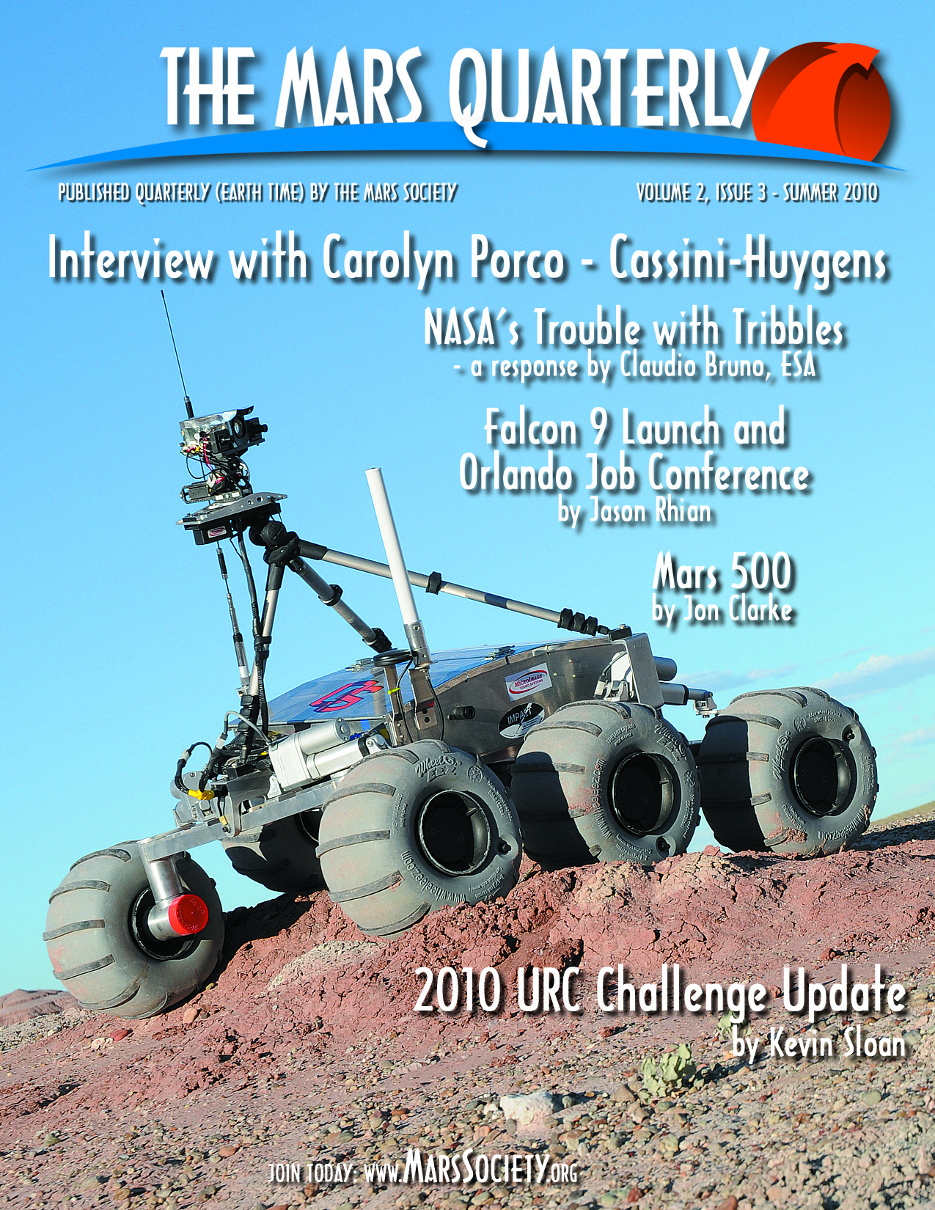

FROM THE FLIGHT DECK

You will notice immediately that this issue of The Mars Quarterly is not in its usual format. Art Director Keith Keplinger left us after the publication of the spring issue, but has graciously provided us with our cover image for this issue. We wish him well as he pursues new opportunities. We are currently seeking a new Art Director, and encourage readers with magazine design experience to apply. Please send your resumes to: susanm@marssociety.org

On to Mars!
- Susan Holden Martin, Editor-in-Chief

THE MARS QUARTERLY
Summer 2010 - Volume 2, Issue 3

Publisher
The Mars Society
Headquarters
11111 W. 8th Ave., Unit A
Lakewood, CO 80215 USA
www.MarsSociety.org

President
Robert Zubrin
Treasurer
Heather Rose
Acting Executive Director
Lucinda Land
Director of Membership
Patricia Czarnik
Director, University Rover Challenge
Kevin Sloan
Director, Mars Desert Research Station
[appointment pending]
Director, Political Outreach
Gus Scheerbaum
Acting Director, Public Relations
Susan Holden Martin
Magazine Staff
Editor-in-Chief
Susan Holden Martin
Associate Editor
Raul Colon
Executive Editors
Blake Ortner, Gus Scheerbaum, Joseph Webster, Kevin Sloan, Patricia Czarnik
Editorial Team/Copy & Proof
Kenneth Katz, David Christhilf, Debbie Foch, Edie Tepper, Larissa Douglass, Doug Jacques, Eric Harkleroad
Legal
Jocelyn Thomsen, Esq., and
Declan O'Donnell, Esq.

A Note to Readers
The views expressed in articles are the authors' and not necessarily those of The Mars Quarterly, or The Mars Society. Authors may have business relationships with the companies or agencies they discuss.

Reproduction
The Mars Quarterly is published quarterly by The Mars Society, Lakewood, Colorado, USA. Volume 2, Issue 3, © 2010, The Mars Society. Nothing herein contained may be reproduced or transmitted in any form or by any means, electronic or mechanical, including photocopy, recording, or any information storage and retrieval system, without written permission of The Mars Society.

Advertisers send email to
tmq-editor@marssociety.org. Address letters, general inquiries, or send member dues or charitable donations to The Mars Society, PO Box 176, McVille, ND 58254 USA. Please include your full name, address, and daytime phone number. The Mars Society is a 501(c)(3) organization.

IN THIS ISSUE

College Students Tackle the Challenge in Utah 4
NASA’s Trouble with Tribbles 8
Orlando Job Conference – June 4, 2010 14
The Mars 500 15
An Interview with Dr. Carolyn Porco 18
Falcon 9 Launch – June 4, 2010 22
Mars Society Cheers Senate Committee Approval of HLV Funding 26
NASA Authorization Act of 2010 27



June 3-5, 2010

Congratulations to the top three teams:
1. Oregon State University
2. York University
3. The Magma Team


College Students Tackle the Challenge in Utah
By: Kevin Sloan

Since 2007 the University Rover Challenge has pushed students beyond their textbooks, to see if they have what it takes to help open Mars to future explorers. The 2010 incarnation of the event welcomed TASC, Inc. as its title sponsor to help host the largest field to date, and bring forward the toughest challenges ever seen by student-built rovers.
Kevin Sloan

By early February twelve teams from four countries were hard at work. Fast forward four months to the Mars Desert Research Station in Hanksville, Utah, and seven teams were left standing with their rovers ready to compete. Before the weigh-ins even took place the imposing tasks had already weeded out more than a third of the field.

Equipment Servicing Task
Arguably the most complex task of URC 2010, [was] rovers (under control of the student operators) navigating to a mock equipment panel where instructions outlined a series of operations that had to be performed. This included a sequence of buttons, switches, and dangling power cords that had to be acquired and plugged in. On the first day of competition, several teams discovered new bugs and struggled to even make it off of the start line.

Iowa State’s rover made the trek all the way to the panel, only to have their arm’s motor controller burn out, with the resultant smoke seeping out from behind the body panels. The Magma Team from Poland proved that the European contingency was ready to compete, confidently working their way through several of the switches. Not to be outdone, the defending champions from York University navigated the majority of the switches and buttons, and nearly tackled the elusive plug operation; however the slack of the cord proved to be too difficult to handle.
Oregon State, the 2008 URC champion, was the only team of the day that was able to manipulate the power cord and plug it in. In taking first place in this event, Oregon State not only set the bar for the entire field, they successfully demonstrated one of the more complex challenges in modern robotics research.

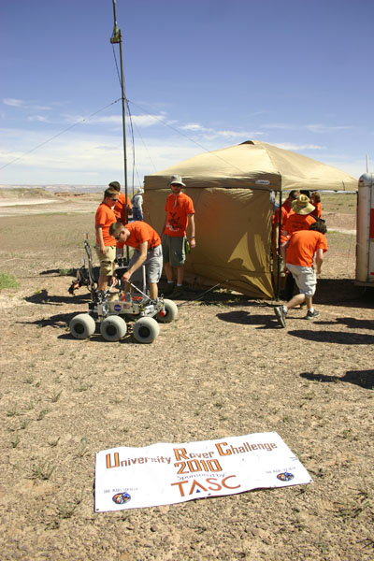
Site Survey Task
Teams were required to use their rovers to find and survey the exact coordinates of several remote field markers. While strategies varied from team to team – some attempted to drive to every marker, while others relied on their cameras and other sensors – this task was dominated by the Canadians. York University and the University of Waterloo tied for first place with 90 points, helping to keep the former in contention to defend the title that they took home just a year earlier.

Sample Return Task
While the world’s space agencies are still years away from mounting Mars sample return missions, the 2010 URC teams got their own shot. Teams had to use their rovers to investigate multiple sites of biological interest, and select one from which to return a sample for further analysis. This was followed by a field briefing to judges discussing the sample and selection criteria used. The Magma Team had a particularly strong showing, tying Oregon State for first place, creating a very close three team battle for first place after three events.

Emergency Navigation Task
In 2008 and 2009, the Emergency Navigation Task has stood as a test that could only be passed by one team each year – and in each of those cases it was the eventual champion. The teams, all eager to make their own history, were provided a last-known GPS coordinate, and a broad relative bearing, for a "distressed" astronaut. Teams had 40 minutes to rescue the astronaut (by delivering a package of critical supplies), however only 20 minutes to receive the maximum points.

The Magma Team came incredibly close, passing just 4 meters from the astronaut. However, with the rover’s camera looking in the wrong direction as they drove, they failed to see the target. Throughout the remainder of the event, other teams had trouble finding their way in the difficult terrain of the desert. After attempts launched by six teams, nobody had found the astronaut.

Oregon State, the last team of the day, set out on a perfect bearing, located an ideal observation point, was able to utilize a high camera mast to immediately locate the astronaut. When they reached the target, and the judges stopped the clock, it read an unbelievable 3 minutes and 38 seconds into the event.

When the dust had settled at MDRS, three countries were represented on the podium. Oregon State took first place with 315 points. They were followed in second place by York University with 209 points, and The Magma Team in third place with 203 points.

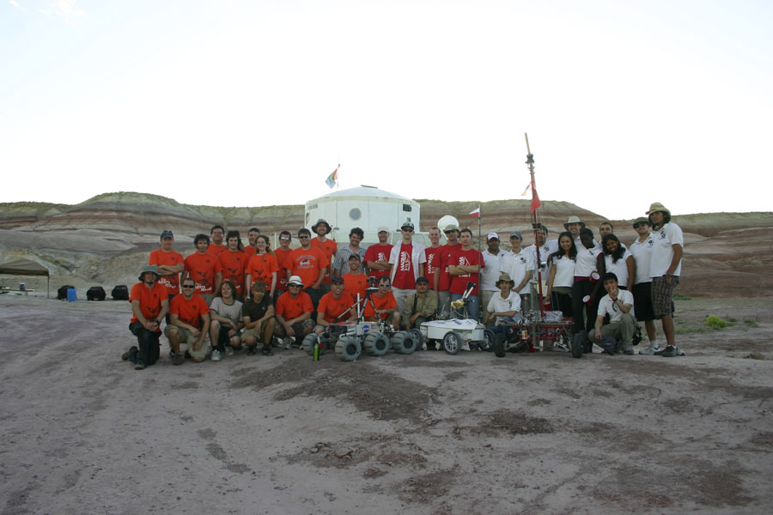

Dave Manser, URC judge and a Director of Technology at TASC, hoped that the entire field of competitors would walk away from the competition with feelings of enthusiasm and inspiration. “Today’s university students will be the Mars pioneers. I challenge you to be the scientists, politicians, fundraisers, promoters, entrepreneurs, and dreamers for this quest,” said Manser. “You will be at the peak of your professional lives when the moment in human history to go to the red planet finally arrives. This is your generation’s destiny.”

Kevin Sloan is a systems engineer in the Washington, DC area. He serves as the Director of the University Rover Challenge, and also sits on the Steering Committee of the Mars Society.

Connect with URC on Facebook.
Check out all the action at: http://www.marssociety.org/portal/c/urc/2010-urc-archive/urc-2010-updates-from-the-field
This year’s URC was sponsored by: 
http://www.tasc.com/

THE MARS SOCIETY is a private, non-profit organization, dedicated to furthering the cause of humans to Mars through education, outreach, and privately-funded research. We need your support to continue our groundbreaking research and educational programs. Donations to THE MARS SOCIETY are tax-deductible to the extent allowed by law. Please consult your tax advisor.
[ ] Friend $200-$499
[ ] Enthusiast $500-$999
[ ] Benefactor $1,000-$1,999
[ ] Explorer $2,000-$4,999
[ ] Visionary $5,000-$9,999
[ ] Pioneer $10,000-$99,999
[ ] Golden Orbit $100,000 or more
………………………………………………………………………………………………………………
Method of Payment: [ ] Check [ ] Credit Card [ ] Money Order [ ] P.O. (on approval)
Credit Card Type: [ ] Visa [ ] MasterCard [ ] Discover [ ] Am Ex
Card Number _______________________________ Expiration Date _________________
Name as it appears on Card: _________________________________________________
I hereby authorize THE MARS SOCIETY to bill the above gift to the Credit Card specified above. Total = $ _______________
Authorized Signature: ___________________________________________________
Print this form, fill it out, and send it with payment to:

THE MARS SOCIETY
P.O. Box 176
McVille, ND 58254

Gifts made by Credit Card may be faxed to: (307) 459-0922
THANK YOU FOR YOUR GENEROUS GIFT.

NASA’s Trouble with Tribbles

A Reply by Dr. Claudio Bruno
Dr. Claudio Bruno (Image: ISIS)
I was very interested in the [opinion] piece NASA’s Trouble with Tribbles http://www.marssociety.org/portal/nasas-trouble-with-tribbles/ by Mr. Brian Enke, and I would like to clarify one or two of the issues he raised. I chair the Physical Sciences Advisory Group of European Space Agency (ESA) that supplies this latter with critical evaluations of proposed space experiments and in-space industrial work.
The starting point of Mr. Enke is the 'clue' in Augustine Committee (AC) dealing with the safety of human exploration (HE). To Mr. Enke, that is puzzling, and "...reflects a paradigm of fear...” Rewind to a couple of years ago, at an ISTS (International Symposium on Space Technology and Science) meeting in Japan. By chance, there I attended a session on space radiation and, in particular, on health risks associated to working in the lunar environment. Fast forward to a year and a half ago, when at ESA we started having joint meetings between the Physical Sciences and the Life Sciences people. In casually discussing the effects of space radiation, I was struck by the LS people casually citing worrisome data on the effects of Galactic Cosmic Radiation and Solar Radiation (including flares: GCR and SR), indicating prolonged exposition (months) results in chances to get cancer in the several percent.
That started a series of events, as I became very curious about the issue of radiation hazards outside the Van Allen belt. Today, after much reading, a thesis, a paper written with one of the radiation experts, and many conversations with the NASA people who know about this issue, I am perhaps wiser and certainly somber. My conclusions, based on what we know and on work I did myself with EU experts, are, in extreme synthesis:
1. Hardly any mission planner of Mars Missions in EU knows about the effects of GCR/SR. The gap with experts in Life Science and human health in space is very wide.
2. A conventional Human Mars Mission (HMM), lasting 6 to 9 month one-way, and assuming shielding by a conventional spacecraft structure, results in a statistical chance about 1/7 of getting some form of cancer.
3. A lunar base requires 1 to 1.5 m thickness of regolith to reduce cancer chances to negligible after 1 year. These data have implications for work on the Lunar surface as well.
4. One of the NASA experts whom I asked about feasibility of a reference HMM, based on cancer risks, told me: "forget it!".
5. Shielding against steady SR for months on end is feasible, but requires thickness of order 1-2 cm with aluminum alloys. Against solar flares (about two orders of magnitude more energetic and still unpredictable) the mass required would preclude a workable solution on the lunar surface. A safe house is necessary.
Shielding against GCR is arguable, and depends on which part of the GCR spectrum one looks at. In fact, the highest GCR energies are 6 to 8 orders of magnitude larger than those achievable in CERN's LHC. The corollary is, we can't even simulate these energies on the ground. Fluxes, however, are 'relatively' small. At the other end of the spectrum, energies are 'only' MeV, but fluxes are orders of magnitude larger - hence the opinion of the NASA expert.
6. To conclude, GCR and SR are the major problem in HMM, but have not even begun to sink in the consciousness of mission planners. It is the hippo in the living room, but most people don't see it. However, this knowledge exists within NASA.
This said, here is a possible explanation for the clue' in the AC report (it is a personal conjecture). Who is really familiar with this issue finds him-/her-self in a bind: if one breaks this issue open, chances are that any interest about HE would be damped or killed in Congress. If the issue is left to specialists and is not publicized, there will be no pressure and no moneys to find a solution.
Hence, the puzzling emphasis on technologies: it would buy precious time, something like saying, "right now we don't know how to reduce health risks, so let's develop means of coping with them. Once we have solved them, then and only then we can talk HMM."

If, as it seems from what we know, GCR and SR are the major issue in HE and HMM, the only logical way to approach a solution is to shorten drastically transit time to Mars. That implies nuclear propulsion of some sort (nuclear electric, e.g., VASIMR, or nuclear thermal, or a combination). On paper, the former is workable, as it may shorten a HMM by a factor 2 at least, compared to a conventional (chemically-powered) mission. Again, this is a technology that needs to be developed, and that is also why the Russians are talking about nuclear-powered Mars missions.
Is this conjecture plausible? Yes. Is it the reason behind the AC report and its consequences as we see them now? Maybe, but whatever motivated it, the GCR/SR issue is here to stay, and unless R&D on it is done, will stay unsolved.
I wrote this for the general space community, but I have all references one would like (or dislike...) to back these statements
Best regards,
Claudio Bruno
Chair, PSWG of ESA
Claudio.Bruno@uniroma1.it

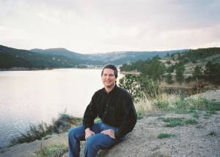
RESPONSE FROM BRIAN ENKE:

Claudio - THANK YOU for your excellent feedback on the article! Indeed, your analysis makes good sense... a gloomy estimation of the effects of the radiation environment outside Earth's magnetosphere may indeed have motivated the
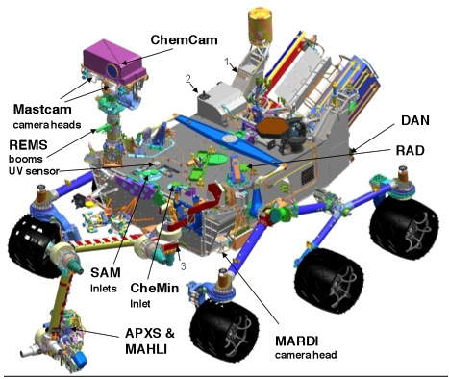
Augustine Committee to ignore a serious discussion of Mars in their final report. They do mention radiation several times in other sections, so they were certainly aware of the issue and viewed it as an urgent one.
Your in-depth discussion of the risks and responses also strongly supports the main point I raised about a "paradigm of fear" at NASA or within Augustine's committee. I'm not sure that was your exact intent, so I'll try to better explain that reasoning below (in case it wasn't).
We currently know some things about space radiation effects (from MARIE or from extensive ENA/magnetosphere/biological studies here at SwRI or Harvard or Lawrence Livermore or elsewhere) and we don't know other things - like (among others) an exact mix and level of exposure on the Martian surface - which SwRI's RAD instrument on Curiosity should soon answer if Curiosity ever gets launched.
Brian Enke (Image: SwRI)

Faced with the current unknowns, how should NASA (or ESA or RSA) react?
If driven by a paradigm of fear, an agency would assume the worst-case scenario in terms of impact on BOTH the crew and the mission (key point there - the two are very different things... and the relative priority of Loss-of-Mission and Loss-of-Crew is an important cultural assumption). Such an agency would devise ever more elaborate ways to research and eventually minimize the radiation risks - perhaps by using nuclear propulsion to shorten the length of the in-space part of the mission (as you mentioned). Long term, this approach is actually good because we DO want to research and minimize radiation hazards in various ways that make sense. We don't want to kill people needlessly in space, especially via cancer (Note: my mother just passed away in January after a grueling fight with cancer, so I understand this issue and the blind fear and panic it generates oh too well... we were desperate for solutions).
Curiosity Rover
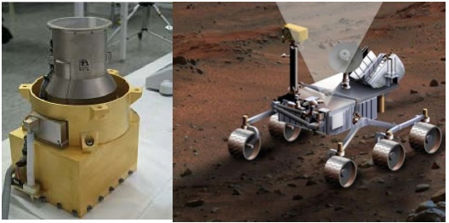

Curiosity (All images courtesy: NASA)

Short term, the approach above is not so good.... because when people are motivated by fear, they make irrational choices.
For example... let's say in reality there's a 30% chance (just creating a probable-highball number totally at random) of any single crew member developing cancer throughout their lifetime if they embark on a 6-month-to-Mars mission with a 6 month return trip - assuming a $5 billion mission using the best currently available mitigation strategies, etc., etc. If we send six crew members, we therefore have a probability distribution of casualties ranging anywhere from 0 to 6, but probably centered around 2.
So... how does a space agency react to this sobering news?
An agency enmeshed in fear-based paradigms would say, "We can't launch the mission until we have very little additional risk of anyone dying from radiation effects... and therefore we're going to invent new methods of shielding, hull composites, propulsion, medical mitigation, etc, and someday we'll be ready." So thus we will do, spending $200 billion on research and delaying the first mission 20 years, then mounting a complex $100 billion mission to Mars or wherever that relies upon way-more fragile systems (say we deflect GCRs via an active EM shield powered by an in-flight nuclear reactor). If successful, maybe our expected crew fatalities from cancer would drop to 1... but 2 crew members might die from the added system/mission fragility (statistically, i.e. with catastrophic system failures there's a smaller chance of total crew loss, which raises the statistical chance of losing any single crew member... fun with statistics). So what just happened? We did all the "right" things and halved the risk of cancer deaths, but in doing so we increased the risk of overall crew deaths plus we spent $295 billion extra plus we lost 20 years. By any definition, this is an irrational outcome. (Another interesting note here is that during those 20 years, one of our crew members may have died from cancer while living on Earth! But I digress...)
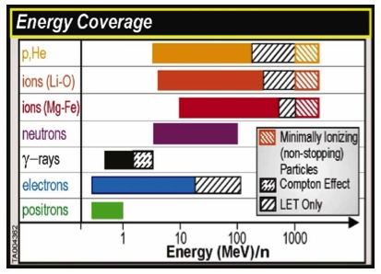
An agency with a healthier culture would say, "OK, we have many serious issues. Based on what we know, what are the current risks throughout the mission?" and "Are the risks justified in terms of the long-term reward?" and "What else can we do to reasonably minimize the overall crew/mission risk?" Currently for
Curiosity RAD measurements

a Mars mission, even if we were unlucky and the radiation unknowns would kill all six (volunteer) crew members on an initial mission, the answers to these questions would still be "substantial", "absolutely", and "quite a bit". Three healthier reactions to address the third question (minimizing the overall risk) I can think of off the top of my head are: 1) send a smaller crew with greater margins; 2) go one-way on the first mission, thereby halving the in-space radiation exposure; 3) focus the initial mission on overall crew safety and the study of the mission hazards (engineering, radiation, zero-G, whatever).
So... go forward with the mission as best you can, minimizing the OVERALL risk to the crew and the program. That's the best path forward.
Other observations about cancer risks, based on my Mom's recent experience with an aggressive form of cancer... if one insists on a two-way mission on the first trip and a crew member develops cancer while on Mars, that crew member is by no means "done for." Mom survived and lived reasonably well for two years after her earliest symptoms, and probably those symptoms took longer to manifest. The biggest key to cancer survival is early detection... and a Mars crew could detect many forms of cancer early. Newer experimental drug treatments could have extended Mom's lifetime and perhaps even thrown her cancer into remission (the recent advances in cancer treatments are simply astounding). If we can keep the ailing crew member alive (and functioning!) for three years, we could possibly return them to Earth for advanced treatment and ultimately save their life. Conclusion: the odds of a cancer fatality on a Mars mission will drop over the coming years even if we do nothing at NASA to actively mitigate the risk. That's good news!
That's enough for now... reactions? Do you see the distinction, and does it make sense?
Cheers,
- Brian Enke, SwRI

Dr. Claudio Bruno is a Full Professor, School of Aerospace Engineering, Department of Mechanics and Aeronautics (DMA), University of Rome, Italy; and formerly, Combustion Group Leader, CRS4 Research Center, Italy (from 1991 through 1998). A list of his publications can be found here: http://www.isis-rd.com/index.php/prof-claudio-bruno.html; http://www.isis-rd.com/index.php/Aerospace-Area/aerospace-area.html

Brian Enke is a Senior Space Research Analyst at the Southwest Research Institute, Chairman of the Rocky Mountain Mars Society chapter, the Denver Space Industry Examiner (http://www.examiner.com/x-2558-Denver-Space-Industry-Examiner), and author of the science fiction novel "Shadows of Medusa" (http://www.shadowsofmedusa.com). Opinions do not represent the official policy of the Southwest Research Institute.

Editor’s Note: The title of this articles refers to an original Star Trek episode “The Trouble with Tribbles” that aired 29 December 1967 (Season 2, Episode 15) © Desilu Productions, 1967. For more information, visit: http://www.startrek.com/database_article/trouble-with-tribbles-the

Orlando Job Conference – June 4, 2010
By: Jason Rhian, Staff Reporter

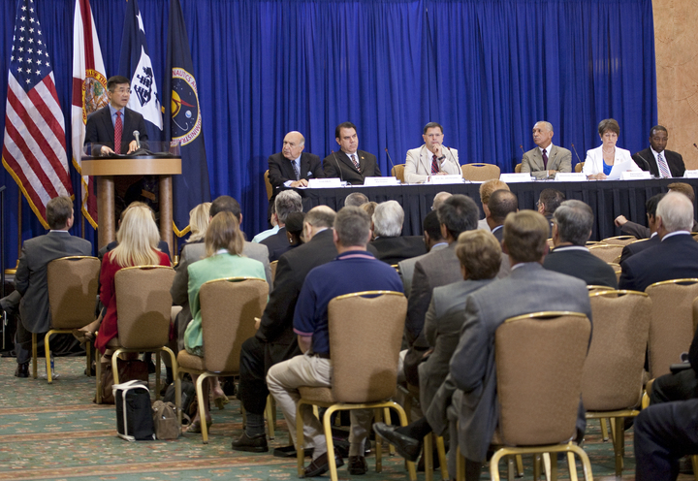
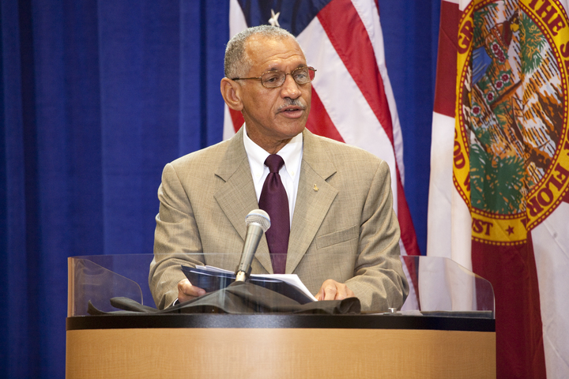
ORLANDO, Florida -- A town hall meeting was held in Orlando on Friday, June 4, 2010, at the Orlando Airport Hyatt Hotel. In attendance were NASA Administrator Charles Bolden and Commerce Secretary Gary Locke. These high-ranking officials were appointed as co-chairs of a jobs task force to alleviate looming job losses in the Space Coast area. The task force was assembled by President Obama.
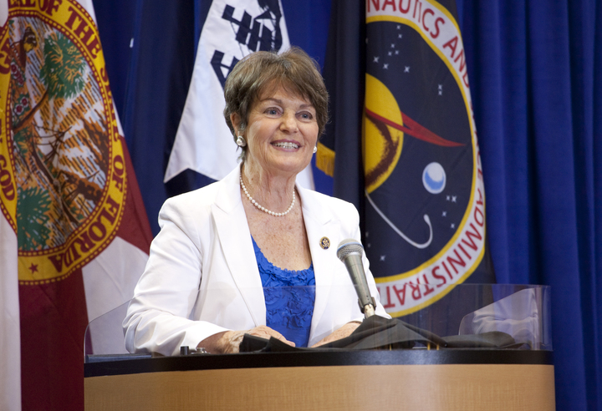
The Orlando Job Conference gathered 100 officials from a variety of different groups and agencies together from around the local area. Also present at the town hall meeting were Rep. Suzanne Kosmas, Rep. Alan Grayson and Space Florida President Frank DiBello.
The task force is funded by $40 million and is comprised of a number of federal agencies. The overriding goal of the task force is to ensure that the region’s economic foundation is more diversified. With the shuttle program scheduled to end after this year it is expected that some 8,000 jobs will be lost at Kennedy Space Center and this will have a dramatic impact on the area. It has been estimated that a total of 23,000 jobs will be lost in Brevard County due to the retirement of the shuttle.
The meeting on June 4 came two days after Secretary of Labor Hilda Solis held a press conference at the Kennedy Space Center Visitor Complex to announce a $15 million grant to help displaced workers find new jobs and gain new education. At the town hall meeting Bolden, Locke and others listened to leaders in the local community to try and find ways to soften the coming impact.
Images courtesy: NASA.


The Mars 500
Dr. Jon Clarke
By: Dr. Jonathan Clarke

Every great achievement in human space flight, from the pioneering flights of Vostok and Mercury, the triumph of Apollo, and the steady progression in long duration missions on the Salyuts and Mir, was built on the shoulders of an army of largely unknown heroes. These were the people who tested space suits and spacecraft configurations, breathed exotic gas mixtures, risked their lives trying out escape systems, and spent long periods in isolation chambers studying evaluating life support systems and as guinea pigs for human-factors research. The first missions to Mars will be no different. A vast amount of ground testing will be needed to test the array of instruments and systems and to design the selection procedures that will select the best people and the best crews.

Mars 500 Candidates
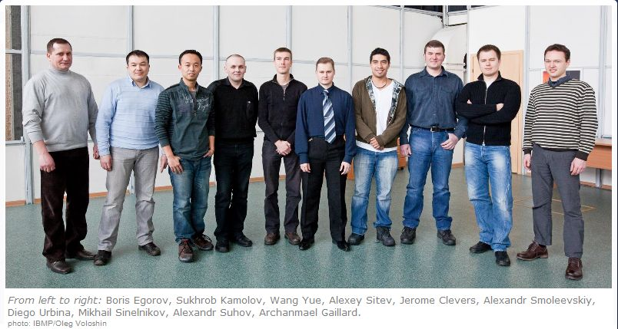

One such test program began on June 3rd, 2010 when six volunteers from four countries were chosen from thousands of applicants to carry out Mars 500, an end-to-end simulated Mars mission at the Institute for Bio-Medical Problems (IBMP) in Moscow. The six are: Diego Urbina and Romain Charles from Europe, Sukhrob Kamolov, Alexey Sitev, Sukhrob Kamolov and Alexandr Smoleevskiy from Russia, and Wang Yue from China. The simulation will last for 520 days and will be the longest and most sophisticated study of its kind ever performed with more than 100 research projects making up the experimental program.

The simulated mission is based on concepts evolved over the past 40 years in Russia for Mars missions utilising solar electric or nuclear electric propulsion with four to six crew and mission times of 460-716 days. Typically 30 days would be spent at Mars with surface crews of two or three. During Mars 500 the crew will simulate 250 days travelling to Mars, 30 days simulating surface operations surface, and 240 days simulating the return journey. During the first phase the time delay in communications will be gradually increased to 20 minutes one way, just as it would on a real mission, in the same way the delay is gradually decreased during the last phase.

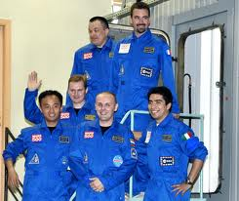
The Mars 500 facility consists of five compartments, four of which are sealed and simulate the spacecraft, the fifth provides the martian surface. The four spacecraft modules are the EU-250, EU-150, EU-100, and EU-50, the numbers are the volume in cubic metres of each module, for a total pressurised volume of 450 m³. Each has its own life support system. The main living module is the EU-150, with individual quarters, a living area, galley, main control room, and toilets. The EU-250 is a utility module, containing a greenhouse, gym, storage and waste disposal facilities. The research module is the EU-100 which also contains an additional two berths and second galley and toilet. The EU-50 module is serves as the simulated lander, with berths for three and its own galley and toilet. The EU-50 is connected to the Mars simulation chamber (SMS module). The SMS has a volume of 1,200 and provides and environment where simulated EVAs will be carried out on a surface of red soil. Two modified Orlan space suits are used for the EVAs and there is also a four-wheeled teleoperated robot.
Image credit: ESA

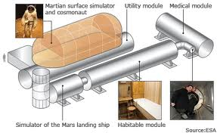

Image credit: BBC/ESA

Mars 500 is the culmination of six years of preparation and anyone interested in the challenges of Mars exploration should follow the experiment closely. The lesson from Mars 500 will also be applicable to long duration missions in Earth orbit and also to the Moon and asteroids.

Links

http://www.imbp.ru/Mars500/Mars500-e.html IBMP site
http://www.esa.int/SPECIALS/Mars500/ ESA site
http://www.mars500.cz/eng/index.html Czech site
http://suzymchale.com/ruspace/mars500.html unofficial Russian blog
http://esamultimedia.esa.int/docs/Mars500/ESA_Mars_500InfoKit_31May2010.pdf press kit
http://www.esa.int/SPECIALS/Mars500/SEMUXB5XT9G_0.html Crew diary

Some Russian Mars mission studies on which Mars 500 is based.
1969 MEK http://www.astronautix.com/craft/mek.htm 630/30 nuclear electric 4 crew
Mars 1986 http://www.astronautix.com/craft/mars1986.htm 716/30 nuclear electric 4 crew
Mars 1989 http://www.astronautix.com/craft/mars1989.htm 716/30 solar electric 4 crew
Mars 1999 http://www.energia.ru/english/energia/mars/concept.html 540/30 solar electric 6 crew

Dr. Jonathan Clarke is Director of Field Research with Mars Society Australia. A Canberra-based geologist with experience in the mineral and petroleum industry, academia, and in government surveys, Jonathan now works for Geoscience Australia. He has worked in every state of Australia, mostly in the arid interior. In addition he has practiced geology in New Zealand, the Philippines, and the Atacama desert of northern Chile, one of the most Mars-like areas on earth. Dr Clarke led the Jarntimarra-1 expedition, and took part in Expedition One in Utah, U.S.A, in 2003 and Expedition Two in Arkaroola in 2004.

Editor’s Note:
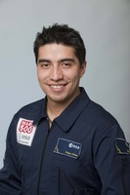
The Mars Society would like to congratulate Diego Urbina on being selected for the Mars 500 project, the first full-duration simulation of a human mission to Mars. Mars 500 is joint project of ESA and the Russian Institute of Biomedical Problems (IBMP). Diego was the crew biologist for Crew 88 at the Mars Desert Research Station (MDRS) located near Hanksville, UT.

Diego Urbina, 26, is of Colombian and Italian nationalities, but considers himself as a citizen of the world. He holds a BSc and a MSc in Electronics Engineering with a focus in microelectronics and optoelectronics, both from Politecnico di Torino, in Turin, Italy.

The Mars Society wishes Diego and the rest of crew buona fortuna and a safe trip.
Diego Urbina (Image: ESA)

For more information on the Mars 500, we invite you to visit:

http://www.esa.int/esaMI/Mars500/

An Interview with Dr. Carolyn Porco
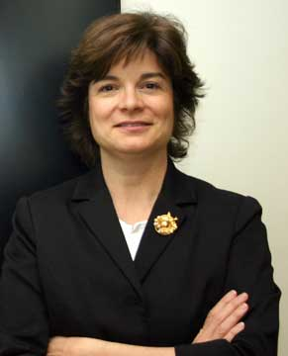
By: Susan Holden Martin

- Congratulations on receiving the Carl Sagan Medal for Excellence in Public Communication in Planetary Science. You have had a remarkable career. Tell us what it means to you to have received this distinguished award.
Dr. Porco (Image: Caltech)
Thank you very much. It means the world to me …. the best possible recognition from my colleagues. I had it as one of my cardinal goals from the very beginning that we on the Cassini imaging team would serve the world in the capacity of extraterrestrial nature photographers in this grand expedition to and around Saturn. And that’s exactly what we’ve done. And as the one representing our experiment to the public, I felt strongly the duty to explain to them not only the science, but the cultural significance of what we have accomplished at Saturn. So, it’s wonderful to know that my efforts in these regards have not gone unnoticed by the people I work alongside.

And of course, I was an enormous fan, and a friend, of Carl, who was the most genteel and gracious person I ever knew. So, the fact that this award has his name on it is an honor so meaningful to me I can’t begin to describe it. I’ve said many times: I lead a charmed existence. And this is just one manifestation of that.

- The Cassini Solstice Mission begins July 1 and runs through 2017. What is the focus of that extended mission?

In broad terms, the Solstice Mission duration and design have been set by the desire to observe Saturn and everything around it over a seasonal cycle: from southern summer, when we arrived in 2004, to northern summer or solstice in 2017. The chance to observe how this very complex system responds to changing solar illumination will allow us no doubt far greater insights into the planetary processes responsible for making Saturn and its entourage what they are, and [it] was a chance we did not want to pass up.

But our goals are also, in a sense, to tie off loose ends. In the first six years of being in orbit around Saturn, we have discovered a great many things about the planet and its rings and moons….too many to enumerate… but for starters: liquid hydrocarbon lakes and seas on Titan, a possible liquid-water habitable zone beneath the south pole of Enceladus, a giant vortex at the south pole of Saturn, small moonlets plowing through the rings, and walls of rubble miles high towering above them, and on and on it goes. All of these have come as result of being in orbit, and having many opportunities to look, and come back and look again.

Well, the Solstice Mission will give us many more opportunities to come back and look again at the most exciting of our initial discoveries … to follow the moonlets in the rings (which will tell us how the forming planets interacted with the solar nebula from which they grew), to gather more information on the jets erupting from the south polar terrain on Enceladus (to ascertain if they really do arise from pockets of liquid water), to look for jets on other icy moons, to look in greater detail at the dynamics of the rings, and so on. There is an immense amount left to be done, and we have planned a rich program of observations over the next 7 years. So stay tuned…..

- Will the budgetary constraints at NASA affect the Cassini mission?

Well, so far, so good. We Cassini scientists have been given in the next year a very generous budget, all things considered, and it may be a year or two more before our budget really begins to nose-dive. Still we need to trim our sails, and we’re now developing more streamlined ways to do what we need to do, like doing less complicated observations and fewer of them. Of course, politics being what it is, I suppose we could suffer a budget cut deeper and earlier than we planned, and then more adjustment will be needed. But so far so good.

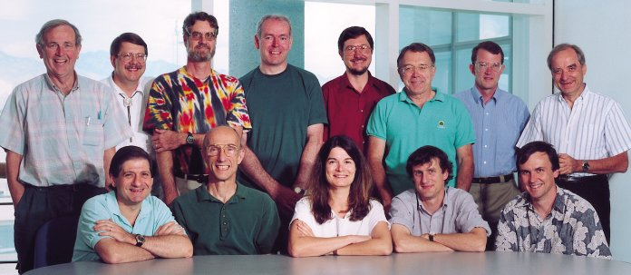
Cassini Imaging Team (Image: NASA)

- What do you believe will be Cassini-Huygen’s most important legacy to future exploration missions?

What will be our legacy? Take a good look at Saturn through any backyard telescope. Remember what you saw: a small fuzzy object, with almost no detail… wavering, distant, remote. Now go to our website (http://www.ciclops.org/ir_index_main/Cassini?js=1) and take a look at some of the images we’ve returned from Saturn. Notice any difference?

We’ve taken a planetary system that is 10x farther from the Sun than the Earth, and have come to know it intimately. And though the process of study and evaluation is still in its infancy, I can promise that eventually from what we’ve seen at Saturn, we will come to understand far better the processes involved in the formation and evolution of planets, the behavior of disks of matter, and the formation of solar systems from them, around other stars, and maybe, just maybe, something about the origin of life itself.


Image credit: CiCLOPS

Of course, let’s not forget that future explorers to this sector of our solar system – whether they be robotic or human – will one day rely on maps made from our images to find their way among the moons of Saturn.

And, as if that all weren’t enough, along the way we have given everyone on our own planet the chance to witness the extraordinary … an alien wilderness of astonishing, spellbinding beauty, and a chance to regard ourselves, with all due honesty, as the remarkable thinkers, dreamers and explorers that we really are.

Am I proud of the legacy that we will leave behind? Just a little.

- Are you still teaching?

Not classroom teaching, no. But I consider that I am teaching whenever I speak or otherwise engage the public about Cassini or planetary exploration. Scientists are always teaching when they explain what they do to the non-scientist. And we should all be very mindful of that. The public needs to know, and I feel has great desire to know, what it is we do and why we do it. It’s our duty and obligation to tell them. So, whether I’m speaking or writing for the CICLOPS website, I’m teaching all the time!

- Did you contribute to the development of the materials used in the Cassini-Huygens Education and Public Outreach Program?

Only whatever images of ours that they use. I do my own outreach.

- Have there been any unique successes that you would like to mention to our readers?

Well, we’ve established the CICLOPS Alliance, and of course the CICLOPS website. And people have enjoyed my Captain’s Logs, which I haven’t updated in months, and so I’ve got to get back to that …. soon.

Members of the CICLOPS Alliance get to play our Golf Sector 6 game where folks can tee off on the moons of Saturn. I'm told parents have great fun playing it with their kids. I’m really proud of that one. It's great fun, and teaches a bit about the gravity of different sized objects, and I'm very proud of it.

http://www.ciclops.org/sector6/golf.php?js=1

- What advice would you give to aspiring planetary scientists who hope to follow in your footsteps?

As demanding and often frustrating as this path has been, I feel incredibly lucky to have been able to do with my life what I’ve done. Being a planetary explorer is the most meaningful, rewarding and spiritually rich calling a person could follow. To be so small and yet reach so far … what did I ever do to allow me that? I don’t know. But as I said already, I’ve led a charmed existence. And I thank the great singularity in the sky for that!

One of the world’s leading planetary scientists, Dr. Porco is the Cassini Imaging Team Leader, and Director of CICLOPS at the Space Science Institute, Boulder, CO. The Cassini mission is currently exploring Saturn and its system of moons and rings. Dr. Porco has also participated in important roles in other outer solar system exploration missions, including the Voyager probes to Jupiter, Saturn, Uranus, and Neptune, and the New Horizons mission currently on its way to Pluto and the Kuiper Belt.

http://ciclops.org
http://twitter.com/carolynporco
http://www.facebook.com/carolynporco

Falcon 9 Launch – June 4, 2010
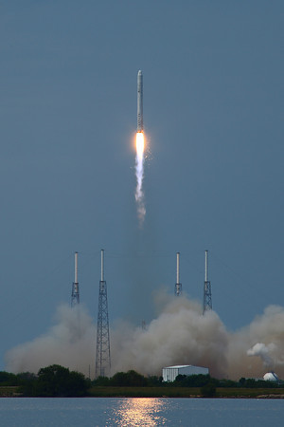
By: Jason Rhian, Staff Reporter

CAPE CANAVERAL – Space Exploration Technologies (SpaceX) displayed that it has the “right stuff” June 4, 2010, when the private space company launched its Falcon 9 rocket on its maiden flight. The launch took place on the second attempt to send the rocket aloft from Space Launch Complex 40 at the Cape Canaveral Air Force Station. The Falcon 9 lifted off at 2:45 p.m. EDT just 15 minutes before the day’s launch window was scheduled to close. The payload for this first mission was a prototype of the Hawthorne, CA based company’s Dragon spacecraft.

Weather was a day-long concern with poor weather predicted to hit the Kennedy Space Center area at 11:30 a.m. – a mere ten minutes after the first launch attempt was slated for. However, it was technical issues not thunderstorms that caused the first launch attempt to slip to 1:30 p.m. A problem with communications between the rocket and ground appeared when the swing-back arm was retracted. This, however, was quickly turned into a non-issue by SpaceX technicians.

Safety concerns caused further delays when a boat encroached into the restricted safety zone. These took some time to clear and were eventually resolved when the boat was intercepted by helicopters and instructed to leave the vicinity immediately. Once it was outside the restricted zone, the boat was pulled over by the U.S. Coast Guard and its crew interviewed.
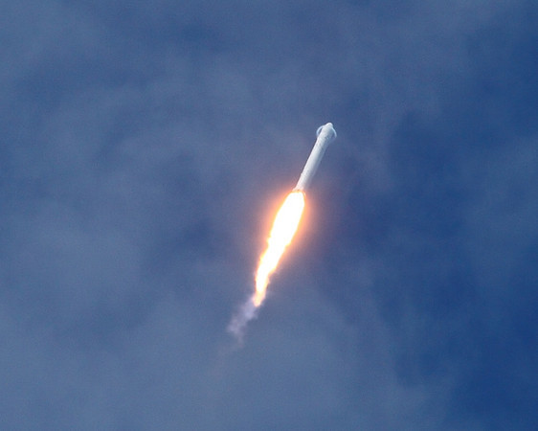
The first scheduled launch time was slated for 1:30 p.m. EDT. Everything proceeded according to schedule and the countdown clock ticked down to just two seconds before launch – and then the launch was aborted. Computers monitoring the launch noted that one of the Falcon 9’s nine Merlin engines was outside its normal operating parameters and shut the rocket down. As this point in time it seemed that the Falcon 9 would fall prey to the usual statistics for first time rocket launches.

It is estimated the only 50 percent of all first-time launch vehicle attempts end in failure whether that is a scrub or a failure of a more catastrophic nature. It would have then been very understandable if Falcon 9 mission managers decided to regroup and try again the following day. Instead the SpaceX team worked the problem and found that it was still possible to attempt a launch that day – but it would be close. The second launch attempt was slated for 2:45 p.m.

With the numerous events that had cropped up during the day it seemed highly unlikely that the Falcon 9 would be lifting off this day. However this time there would be no stopping the launch. The countdown clock ticked down to zero and the Falcon 9 roared off the launch pad on a slow, steady arc across the Florida sky. As it hit the thin air the rocket formed a white plume and it just kept going. The Falcon 9’s key mission objectives were successfully met one by one.

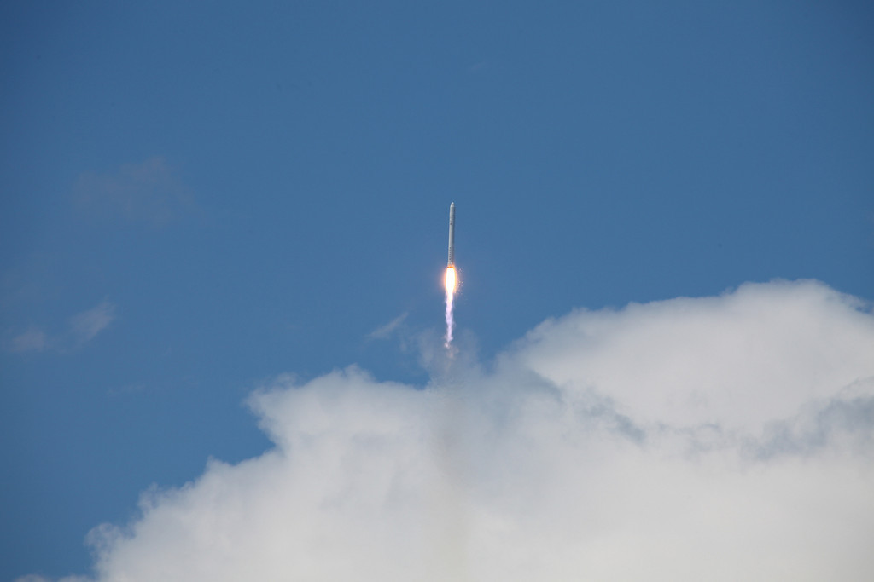

“The things we’ve done here today we’ve built on the shoulders of the work that has been done previously. This is really SpaceX extending the work of great rocket engineers and scientists before us,” Elon Musk CEO and CTO of SpaceX said recently in a teleconference. “We look forward to taking it even further in the future, and ultimately, one day perhaps even to Mars.”

SpaceX won the $16 billion NASA Commercial Orbital Transportation Systems (COTS) contract. By doing so, SpaceX is required to launch 15 Falcon 9 rockets. Three of these launches will be test flights, with the final 12 carrying cargo to the International Space Station. With the first test flight completed, it is predicted that the first supply mission could take place as early as next year.

Jason Rhian is a graduate of the University of South Florida who completed two NASA internships. He currently covers space issues for Examiner.com, Spacevidcast and SpaceRef.com. Jason has covered some 14 space shuttle and numerous unmanned launches. His group affiliations include the National Space Society, the NASA/JPL Solar System Ambassadors, the Astronaut Scholarship Foundation Ambassadors, the Florida Public Relations Association, and the Google Lunar X-PRIZE team - Omega Envoy.

Images courtesy of: Alan Walters www.awaltersphoto.com
Paying the Way – How Do We Get a Return on Our Martian Investment?
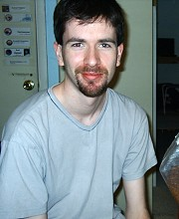
Pete Collins
Birmingham, UK
pete.james.collins@googlemail.com

We have the technical know-how to send humans to Mars if we choose. Where the whole endeavour fails, of course, is money.
Pete Collins
Crew 27- MDRS
The obvious source of money is government spending. This worked extremely well to get to the Moon. The goal was set in 1962 and achieved seven years later. That is a phenomenal achievement, but the effort could not be sustained for long after the race was "won".

That success makes the solution for Mars seem so simple: persuade the President, get money. But the space race was a product of the Cold War; a very different time to the present, which lacks the burning imperative to climb hard and fast toward the stars. Unless a new space race begins, such an imperative will continue to be absent.

I have read many articles pointing out how much we spend on various fripperies (pet food, cosmetics, etc), and comparing this to how much we would need to send people to Mars. "Surely, if we spend this much money on that, we would be willing to spend the same amount on sending people to Mars!”. I agree with the logic, but if that argument worked, it would have done so by now. Nearly four decades of a theory failing should be enough to persuade us that it will not work without a huge change in global circumstances, one which we should not wish for. International cooperation is often the hope of space activists looking for a way to make the costs sound more palatable, but the International Space Station continues to show that this approach will achieve very little.

Could prizes get us to Mars? Virgin Galactic will be taking paying customers to sub-orbital space. This venture owes its development to the Ansari X-Prize – this $10m prize leveraged over $100m in development money in pursuit of it. These and other enterprises should substantially bring down the cost of space flight, even if they don’t yet get us anywhere near Mars. Robert Zubrin has outlined twelve prizes that the U.S Government could sponsor, for various intermediate goals along the way to a full human mission to Mars. Whilst this is still government funding, it has the virtue of encouraging a wide range of innovative approaches which will only cost the taxpayer a cent if the goals are actually achieved.

Often we assume the value of exploration is self-evident, but what is the value of Mars? The one Martian export so far has been data. The Mars Exploration Rovers cost $820m for the initial 90-sol mission, so is the data “worth” this much? How much extra would the data generated by a field scientist be “worth”, and would a private organization be able to sell it to NASA? How could ownership rights be used on Mars, in order to allow entrepreneurs to capture the value generated by their investment? What will be the value of raw materials or manufactured goods on Mars?

If we can answer these questions, we might be able to persuade someone to pay.
****

Pete Collins was born in the UK in 1980. After A-levels, he worked in Vietnam for three months as a volunteer for an environmental NGO, Frontier, doing research in Ben En National Park. He then worked for over a year at South East Water, UK, as a chemistry analyst mainly doing trace level pesticide and PAH analysis. He has a BSc in Ecology from the University of East Anglia. His interest in science led him to participate as a member of Crew 27 at MDRS in 2004, and an Open University short course called Exploring Mars. As Crew Ecologist, he was particularly interested in the MDRS Greenhab. He co-authored the Greenhab Ops and Procedures Guide, Grey Water Treatment. He is currently a Graduate Environmental Scientist at Atkins Engineering. Atkins is the UK's largest engineering and design consultancy and the world's 11th largest design firm.

http://desert.marssociety.org/greenhab/ghab03.asp

http://www.atkinsglobal.com/

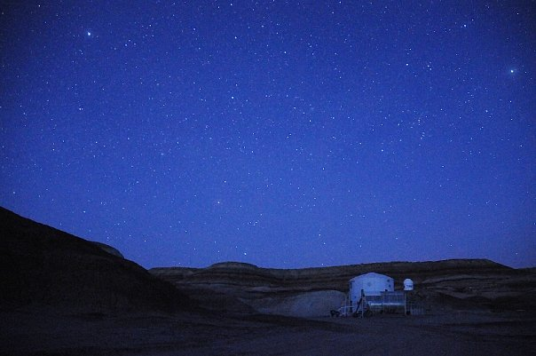
MDRS (Image: Keith Keplinger)

Mars Society Cheers Senate Committee Approval of HLV Funding

By: Mars Society President, Dr. Robert Zubrin

On Friday, July 16, the Senate Commerce, Science, and Transportation Committee unanimously approved the NASA Authorization Act of 2010, with funding included on the initiative of Senator Bill Nelson (D-FL) for the space agency to begin the development of a heavy lift launch vehicle (HLV). The Mars Society cheers this decision.

In a recently released statement, Mars Society President Dr. Robert Zubrin hailed the Senate Committee’s decision to fund HLV development as a vitally necessary step towards restoring a productive human spaceflight program.

“The Senate Committee was absolutely right in insisting on immediate funding of HLV development,” Dr. Zubrin said. “Heavy lift is the essential prerequisite for sending human explorers beyond low Earth orbit. We flew our first HLV, the Saturn V, in 1967, and two years later we were on the Moon. Lacking HLV capability since the 1970s, we have not gone anywhere in 37 years.

“That said, HLV capability, while necessary, is by itself insufficient for a productive human space exploration program. We also need a coherent set of flight hardware elements for the HLV to lift. President Obama has called for NASA to make a mission to a near Earth asteroid by 2025 its proximate goal, as a milestone towards a human mission to Mars by mid-century. These goals are good, but the schedule is unnecessarily slow and costly.

“A mission to a near Earth asteroid requires four primary flight elements, a crew reentry capsule, a space habitation module, an upper stage capable of throwing the capsule/hab combination on an Earth-escape trajectory, and an HLV to lift the lot to low Earth orbit. Under the Senate Committee’s provisions, work on the capsule and the HLV are now funded. The upper stage should also be included within the HLV program, just as the S-IVB was in the Saturn V development. The hab module development, incorporating life support, power, and deep space maneuver systems should be funded as soon as possible.

“If this is done, there is no reason why NASA cannot perform a human mission to a near Earth asteroid by 2016, instead of 2025. Furthermore, with the development of two additional primary flight systems, specifically a Mars entry descent and landing system module, and a Mars ascent vehicle, NASA will possess the complete set of primary flight hardware systems needed to send human missions to Mars. Approached in this manner, we could have our first human explorers on Mars by 2020, instead of 2040 or 2050.

“Since the NASA human spaceflight program costs on the order of $10 billion per year, whether it goes anywhere or not, such an acceleration of the agency’s schedule promises to save the taxpayers $200 to $300 billion. It would thus be extremely wasteful, and in fact fiscally irresponsible, to stretch out the program timeline through sequential rather than parallel development of its necessary flight elements.

“The American people want and deserve a human spaceflight program that is actually going somewhere. Through their action in funding HLV development, the members and staff of the Senate Commerce, Science, and Transportation Committee have taken a critical first step towards making that possible. The Mars Society congratulates Senator Nelson, his staff, and all others who contributed towards this vital action. Now it is necessary to follow through and develop the rest of the flight hardware set so that the HLV is not left waiting forever on the pad with nothing to launch. Instead of yet another decade of stagnation, let us make the coming years ones of bold accomplishment. On to the asteroids. On to Mars.”

Editor’s Note:

NASA Authorization Act of 2010
http://commerce.senate.gov/public/?a=Files.Serve&File_id=20a7a8bd-50f4-4474-bf1d-f0a6a8824b01

Key Elements of the NASA Authorization Act of 2010:
- Authorization of Appropriations – Largely in-line with the President’s fiscal year 2011 budget request to Congress; the bill would authorize fiscal year 2011 to fiscal year 2013 appropriations for NASA.
- Science and Aeronautics – The bill protects a balanced portfolio for NASA, including full funding of aeronautics, Earth and space science, and education, as proposed by the President.
- Space Technology – Investments in technology and robotic capabilities are tied to mission-driven goals and support U.S. innovation and competitiveness.
- Education – The bill supports new education initiatives such as teacher training programs; and increases the investment in the NASA EPSCoR (Experimental Program to Stimulate Competitive Research) and NASA Space Grant program.
- Human Space Flight – The bill couples efforts to national and global needs and challenges; provides a sustainable exploration program with new technologies and in-space capabilities; and future exploration builds off of the workforce, assets, and capabilities of the Space Shuttle and other efforts.
- Shuttle Retirement and final “Launch on Need” Mission – The bill authorizes one last Shuttle flight, based on an independent safety review, to provide necessary support for the extension of the International Space Station.
- International Space Station – The bill extends the Station to at least 2020, which is important for international and commercial collaboration and growth, research, and technology development; and maximizes the scientific return on the significant investment in the Station.
- Commercial Cargo and Crew – If the industry develops as envisioned, this should provide cheaper access to the International Space Station and relieve the U.S. reliance on Russian partners for access to the Station after the Shuttle retires; a strong focus on milestones will reduce risk and assure astronaut safety.

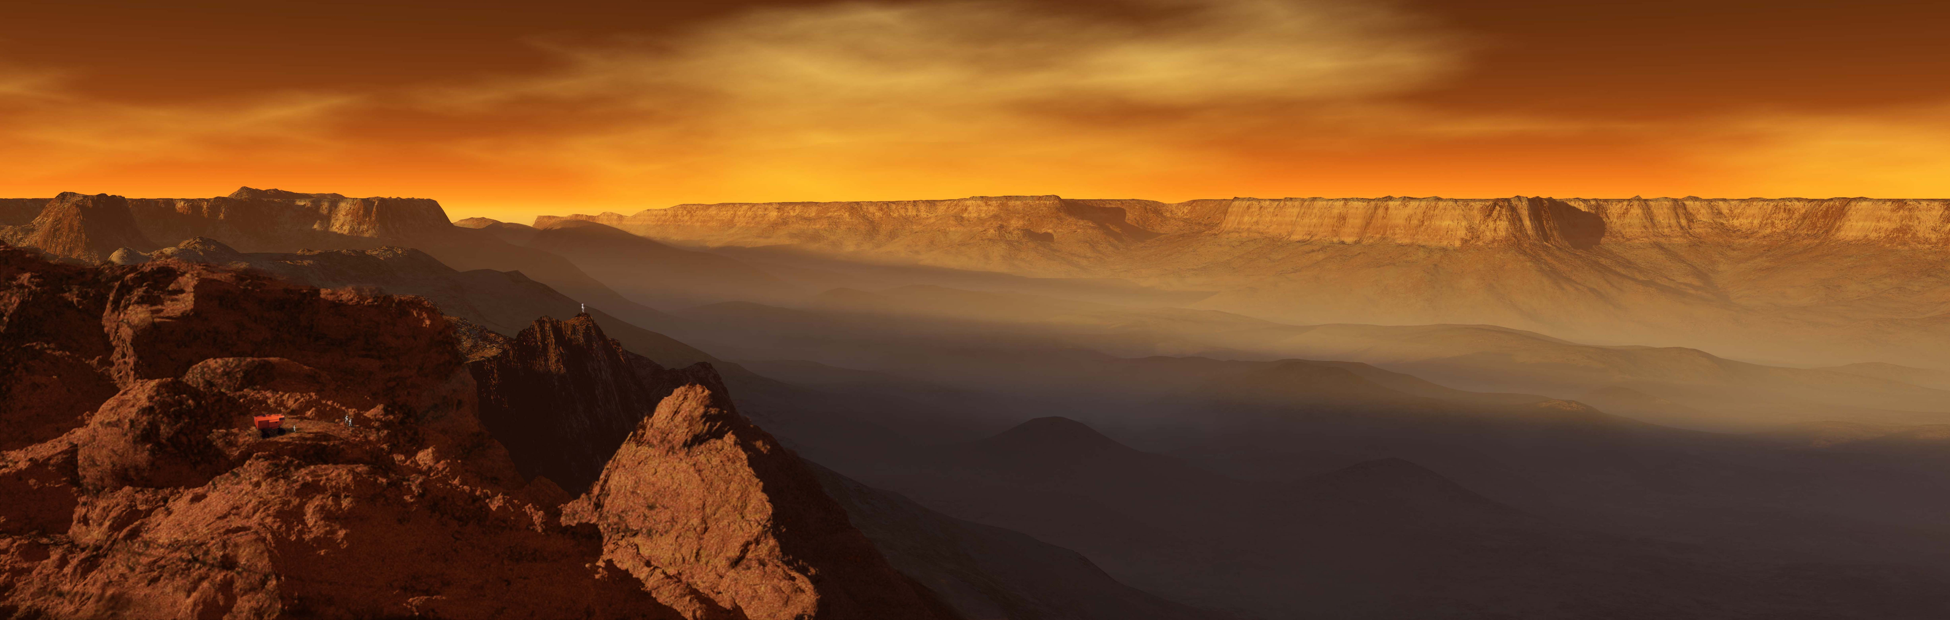
Valle Marineris
Image courtesy of Ron Miller
http://www.black-cat-studios.com/

THE MARS SOCIETY is a 501(c)3 tax-exempt non-profit organization with headquarters in Colorado, USA, committed to furthering the goal of the exploration and settlement of the Red Planet, via broad public outreach to instill the vision of pioneering Mars, support of ever more aggressive government funded Mars exploration programs around the world, and conducting Mars exploration on a private basis. www.marssociety.org

THE MARS SOCIETY
BOARD OF DIRECTORS:
Robert Zubrin
Declan O'Donnell
Scott Horowitz
James Heiser

THE MARS SOCIETY
STEERING COMMITTEE:

April Andreas
Joe Palaia
Bruce Mackenzie
Susan Holden Martin
Buzz Aldrin
Declan O'Donnell
Gabriel Rashaid
Gustave Scheerbaum
James Heiser
Jürgen Hergholz
Kevin Sloan
Lucinda Weisbach Land
Patricia Czarnik
Peter Smith
Richard Heidmann
Robert Zubrin
Shannon Rupert
Sara Spector
Tamarack Czarnik

